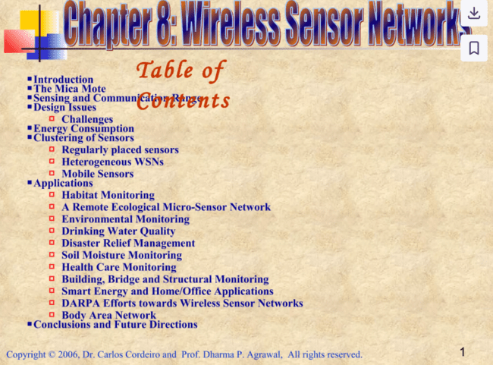

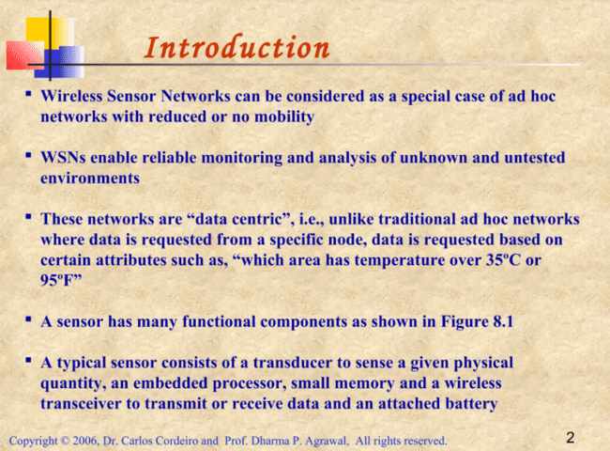

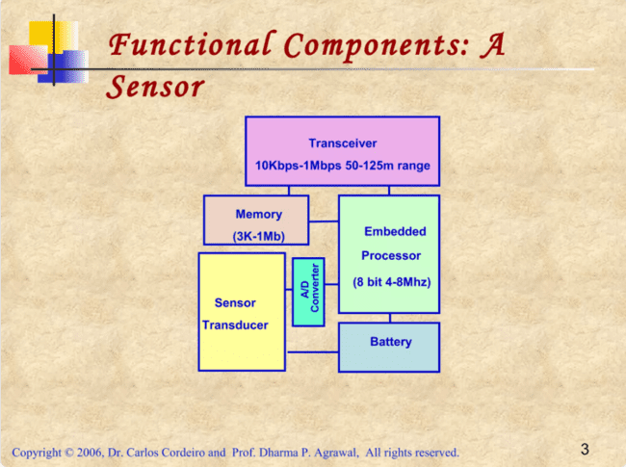



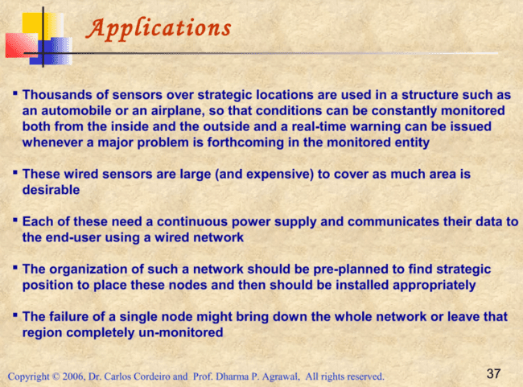

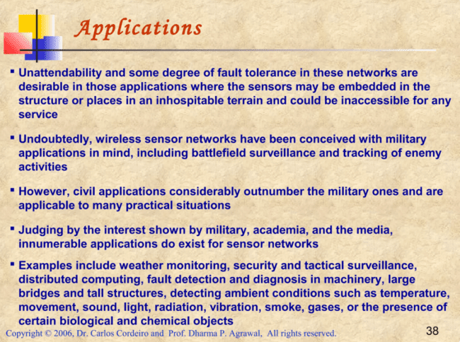

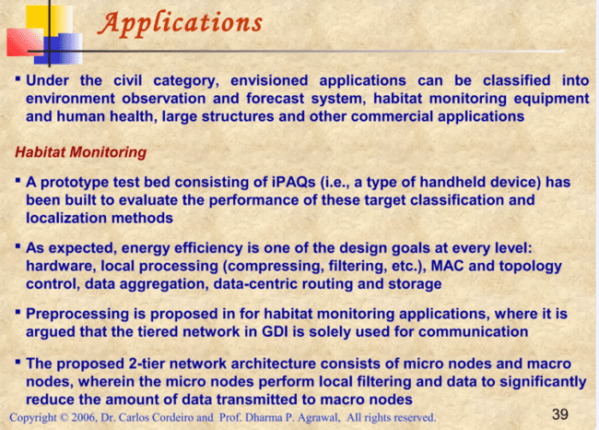

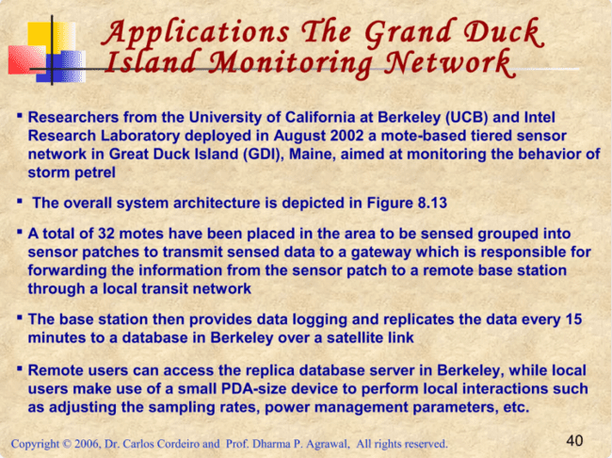

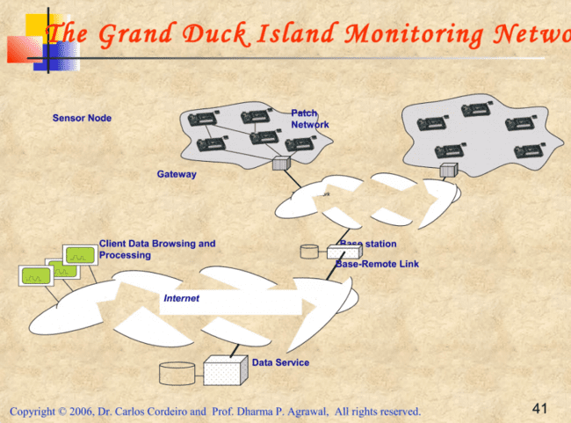

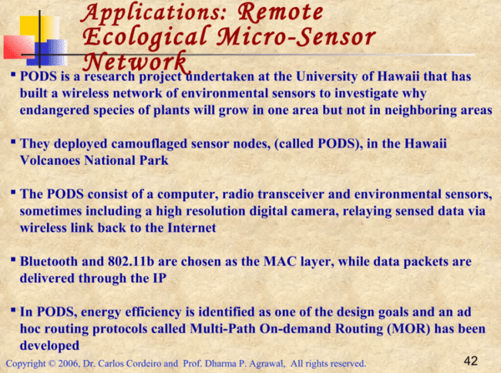

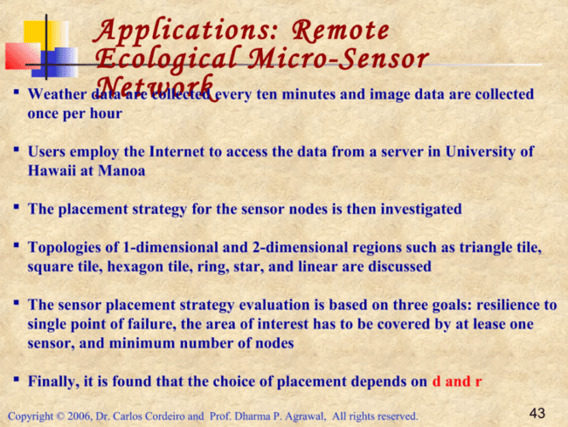



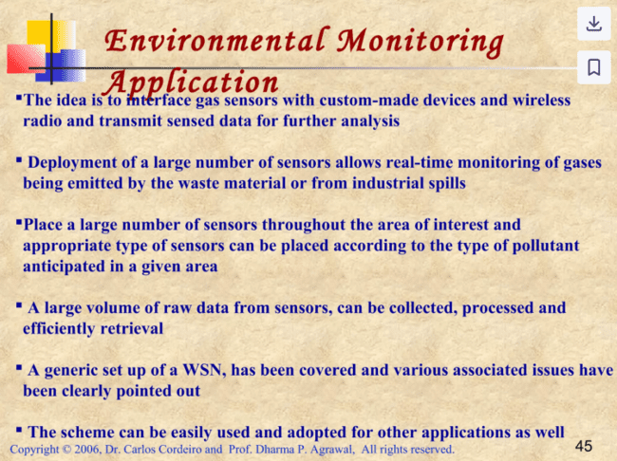

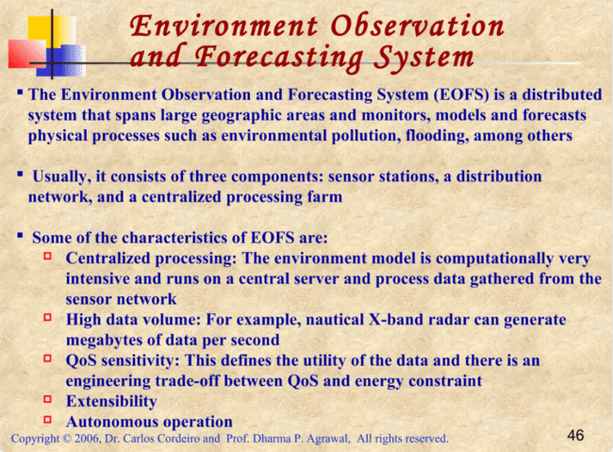









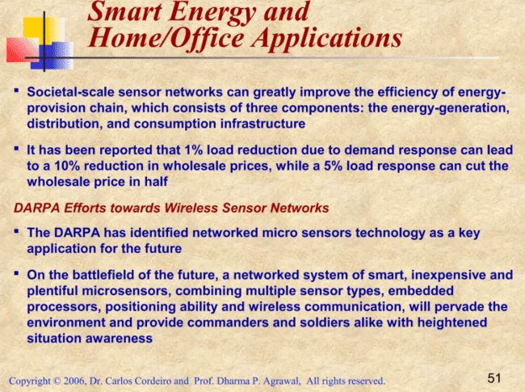

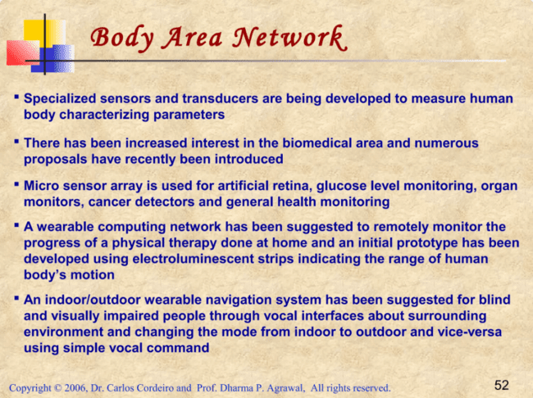

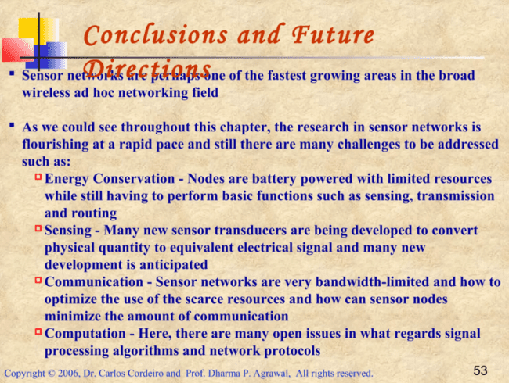

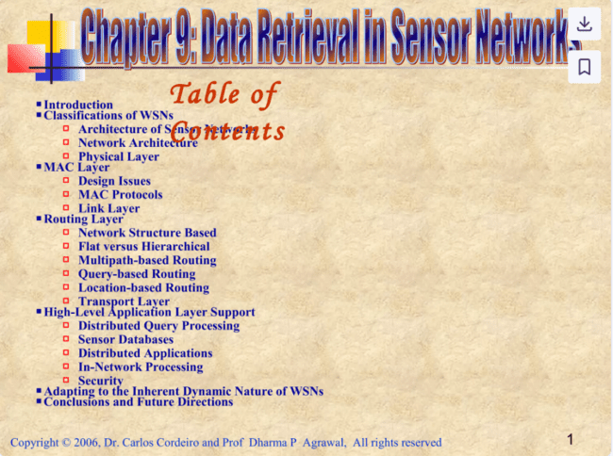

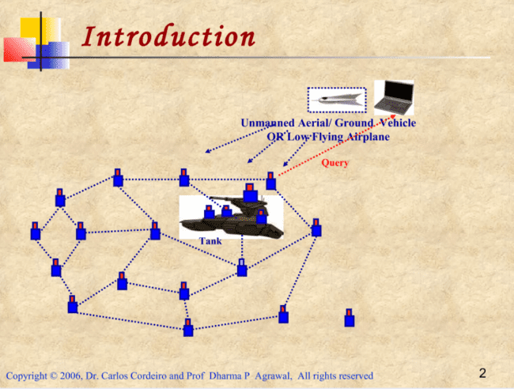

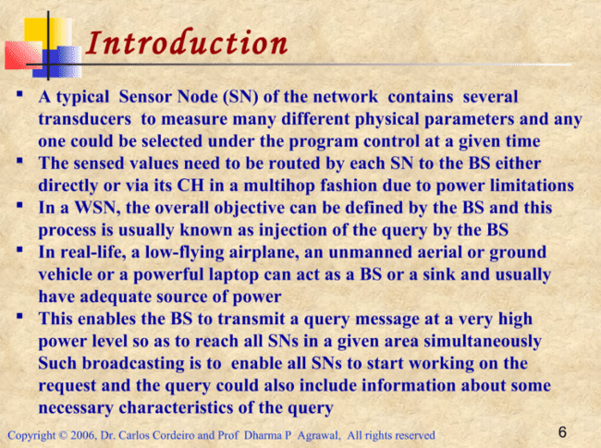

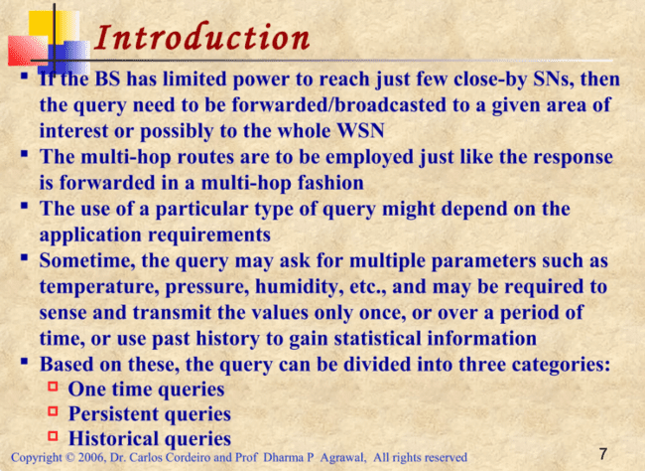

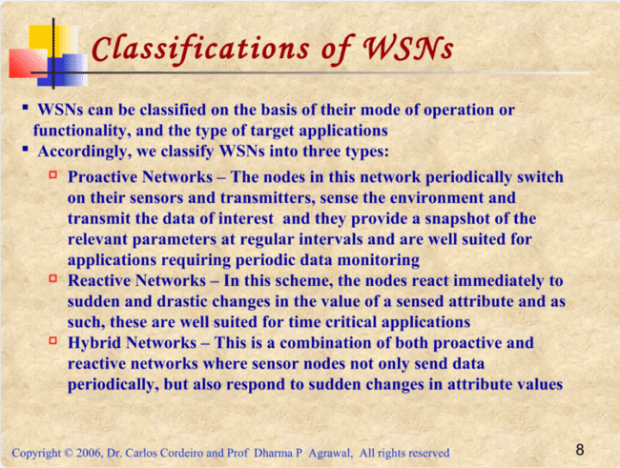

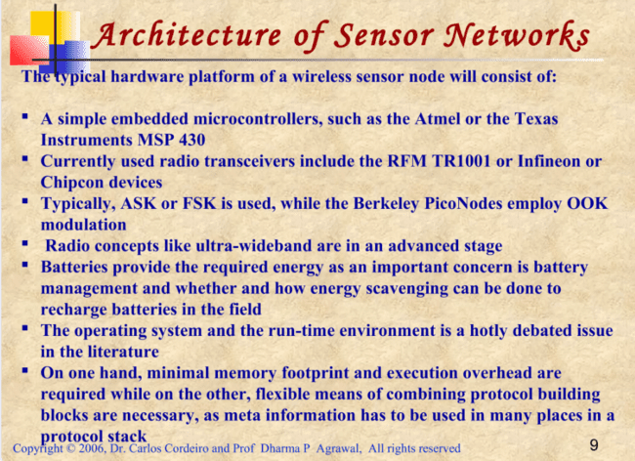

The architecture of sensor networks, specifically wireless sensor networks (WSNs), is tailored to accommodate the specific needs of applications and the communication technologies they rely on. This results in significant variations in both individual sensor node hardware and the overall network structure.

**1. Sensor Node Hardware Components:**

**- Microcontrollers:**

- Sensor nodes are built using simple embedded microcontrollers (e.g., Atmel or Texas Instruments MSP430). These microcontrollers must balance power consumption with computational power, memory, and sleep modes, which influence energy efficiency and responsiveness.

**- Radio Transceivers:**

- Common transceivers include RFM TR1001 and Chipcon devices, which use modulation techniques like ASK, FSK, or OOK (as in Berkeley PicoNodes). Emerging technologies, such as ultra-wideband, offer advances in communication efficiency. A potential breakthrough is the **wake-up radio concept**, which allows sensor nodes (SNs) to remain in sleep mode and wake up when a relevant transmission is detected, reducing power consumption.

**- Energy Supply (Batteries):**

- Batteries are the primary power source, but efficient battery management and energy scavenging (recharging through environmental energy) are critical for long-term operation. Self-discharge and recharge rates, as well as overall battery life, are key concerns.

**- Operating Systems & Run-Time Environments:**

- The trade-off between minimal memory and flexibility for protocol integration is central to the design of operating systems for SNs. Run-time environments that support structures like blackboards, publish/subscribe, or tuplespaces are suggested as suitable for handling the multi-protocol, meta-information-heavy requirements of WSNs.

**2. Network Architecture:**

The architecture of WSNs must ensure both sensing coverage and communication connectivity, which relies on the density of the sensor deployment.

**- Density and Lifetime:**

- The network's lifetime can be defined by either the failure of individual sensors or by a percentage failure rate (e.g., 95% area coverage). Denser sensor deployment provides redundancy, but increasing density can also lead to higher energy consumption and transmission delays due to collisions. The optimal sensor density maximizes sensor lifetime by balancing communication distance and energy consumption.

**- Transmission Strategies:**

- Energy consumption varies depending on whether data is transmitted directly between two sensors or via intermediate nodes. Using intermediate sensors can save energy compared to long-range transmissions (Figure 9.3 illustrates these strategies).

**- Energy-Driven Protocols:**

- WSN protocols must be energy-efficient, focusing on data aggregation and reducing unnecessary transmissions. Redundant or correlated sensor readings can be aggregated to minimize the number of packets sent.

**- Addressing and QoS:**

- Address-free structures may be essential for scalability and energy efficiency, using geographic or data-centric addressing systems. QoS, redundancy, and sensor reading imprecision must be accounted for in the design of the network.

**In-Network Processing:**

- WSNs often perform in-network processing, such as data aggregation and distributed signal processing, to reduce the number of transmitted packets. The exact nature of WSN services is not fully defined, as they do not simply transmit bits like traditional networks.

**- Gateway and Integration:**

- WSNs must be integrated into larger networks via a gateway to bridge different communication protocols. Integration into middleware architectures, like CORBA or Web Services, and services described in WSDL or UDDI present challenges in representing the unique functionality of WSNs.

**- Reconfiguring Tasks:**

- It may be necessary to update the tasks or software of sensor nodes over time, requiring remote reconfiguration capabilities for the WSN.

**Physical Layer**

The physical layer in the context of wireless sensor networks (WSNs) refers to the hardware and communication technologies used to transmit data between sensor nodes. However, limited research has been conducted on developing protocols specifically tailored to the unique needs of WSNs at the physical layer, particularly in terms of **energy efficiency and handling the overhead related to radio transmission (e.g., retransmissions and communication costs).**

Several points about the physical layer include:

**- Energy-Efficient Transmission**: A key focus is on how to transmit data with minimal energy consumption while considering potential retransmissions and overhead. Some energy-efficient modulation techniques have been explored in previous research (e.g., Schurgers 2001).

**- Modulation Techniques for Sensor Nodes**: Research such as that by Gao (2001) addresses the hardware aspects of CDMA (Code Division Multiple Access) and other modulation issues, emphasizing how these impact sensor nodes' performance.

**- Communication Protocol Design**: Shih (2001b) provides discussions on communication protocol designs that are based on the physical layer, offering insights into how the physical layer impacts overall network performance.

- **Standardization Efforts**: Although specific details are not covered, the work being done by organizations like the IEEE (notably the IEEE 802.15.4 standard) is recognized as relevant. IEEE 802.15.4 focuses on low-rate wireless personal area networks (LR-WPANs), which are critical for many WSN applications due to **their low power consumption and cost-effective communication**.

**MAC LAYER**

The MAC (Medium Access Control) layer plays a vital role in wireless sensor networks (WSNs), mainly in regulating how sensor nodes **share the communication medium efficiently while minimizing energy consumption**. The main focus of MAC layer research for WSNs is to keep sensor nodes in sleep mode as long as possible to conserve energy, making it a crucial area of study.

**Key concepts of MAC layer include:**

**Channel Allocation Schemes:**

- **Static Channel Allocation**: Bandwidth is divided among sensor nodes using techniques like FDMA (Frequency Division Multiple Access), TDMA (Time Division Multiple Access), CDMA (Code Division Multiple Access), or SDMA (Space Division Multiple Access). These methods minimize interference but work best in static, low-node-count environments where nodes have predictable data loads.

**- Dynamic Channel Allocation**: This is more suited for environments where the number of active nodes varies, and data generation is bursty (i.e., sporadic). Contention-based protocols such as CSMA (Carrier Sense Multiple Access) are used here. Although these can minimize collisions, they may lead to energy wastage and delays due to retransmissions.

**Hierarchical Clustering and TDMA:**

- In a hierarchical clustering model, TDMA can be used to allocate time slots to each sensor node within a cluster. Nodes transmit data in their designated slots and can sleep during other periods to save energy. This is especially beneficial in both proactive networks (where nodes transmit periodically) and reactive networks (where nodes respond to sudden events).

**CDMA and Intra/Inter-Cluster Collisions:**

- CDMA can be used to avoid collisions between clusters. Though more energy is required per bit transmitted, CDMA allows multiple transmissions using the same frequency, making it useful for inter-cluster communication.

**MAC Design Challenges:**

1. **Node Failure**: When sensor nodes fail, MAC protocols must adapt by forming new routes and adjusting power levels to maintain network connectivity.

2. **Energy Consumption Sources**:

- Collisions: Corrupted packets due to collisions lead to retransmissions, consuming more energy.

- Overhearing: Nodes may waste energy by listening to transmissions not intended for them.

- Control Packet Overhead: The need for control packets to manage network operations increases energy usage as the number of nodes rises or nodes fail.

- Idle Listening: Nodes may waste energy waiting to receive data that is never sent.

**Energy Conservation Techniques:**

- One of the most effective methods for conserving energy in WSNs is periodic sleeping: nodes turn off their radios and synchronize based on a sleep schedule. This reduces the idle listening problem, a major energy drain in sensor networks.

**Scheduling and Reservation vs. Contention-based MAC:**

- Scheduling-based MAC protocols (like TDMA) save more energy compared to contention-based protocols (like IEEE 802.11). However, TDMA requires careful management of cluster formation, inter-cluster communication, and dynamic adaptation to changes in the number of nodes in the network.

In summary, the MAC layer in WSNs faces unique challenges related to energy efficiency, node failure, and dynamic network environments. Various strategies, including static and dynamic channel allocation, hierarchical clustering, and scheduled sleeping, are employed to **balance energy conservation with reliable communication.**

**The Sensor-MAC (S-MAC) protocol:**

1. Energy Efficiency in WSNs:

- WSNs are designed for prolonged operation, making energy conservation crucial since recharging batteries is often impractical.

- Nodes typically spend much of their time in an idle state, consuming similar energy levels in both idle and receiving modes.

2. Low Duty Cycle Operation:

- Nodes in S-MAC operate on a low duty cycle, alternating between listening and sleeping to conserve energy.

- By doing this, S-MAC addresses four primary sources of energy consumption: collision, control overhead, overhearing, and idle listening.

3. Coordinated Sleep Schedules:

- S-MAC nodes communicate and coordinate their sleep schedules to minimize energy waste.

- Each node broadcasts its schedule to neighbors using SYNC packets, helping to prevent clock drift and ensuring nodes follow similar wake and sleep patterns.

4. Handling Different Schedules:

- If two neighboring nodes have different schedules, they can either:

- Listen to both schedules, or

- Transmit data according to both schedules.

- Neighbor discovery is periodically performed to ensure nodes are aware of each other's presence and schedules.

5. Communication Process:

- During communication, a node first performs carrier sensing during its neighbor's listening periods.

- If the channel is clear, it sends a Request to Send (RTS) followed by a Clear to Send (CTS) from the receiver, enabling data transfer during their scheduled times.

- Broadcasts do not use RTS/CTS to avoid potential collisions from multiple responses.

6. Adaptive Listening:

- To reduce latency in multi-hop transmissions, nodes that overhear transmissions can briefly wake up to receive data, rather than waiting for their next scheduled listen time.

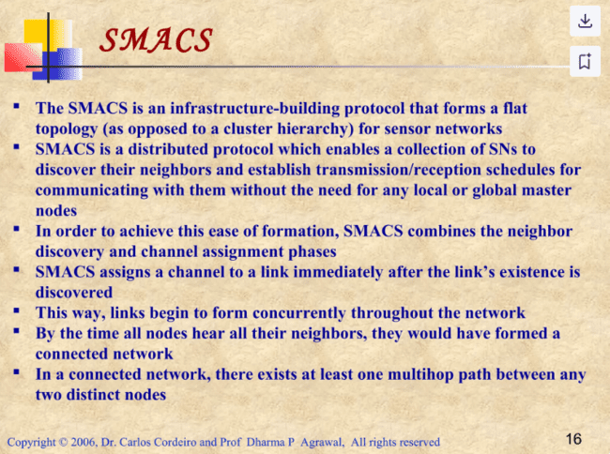

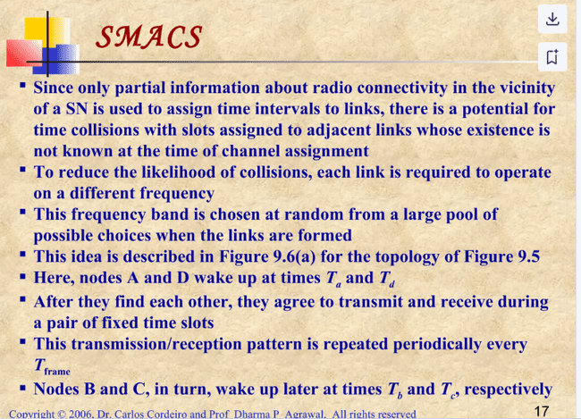

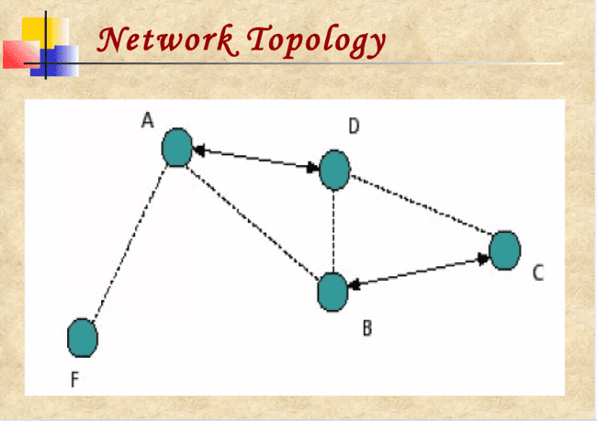

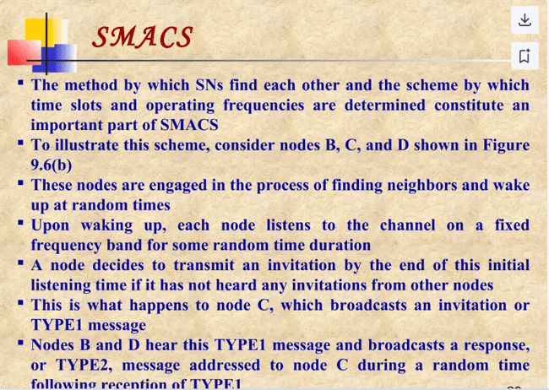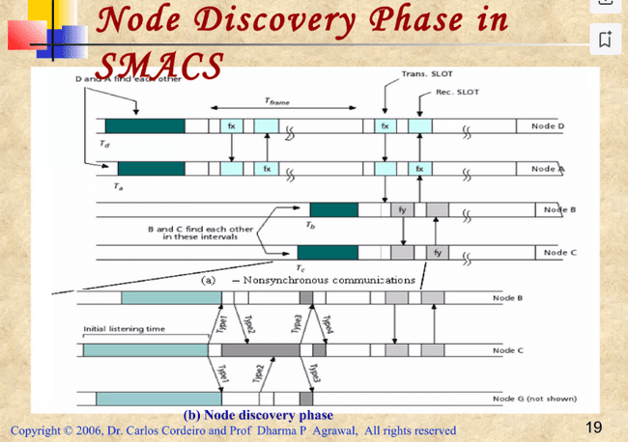

**EAR** **protocol** (Energy and Activity Aware Routing)

It is designed to facilitate communication between mobile and stationary nodes in a wireless sensor network (WSN), particularly where **energy efficiency and bandwidth are concerns**. Here's a breakdown of the key concepts:

1**. Introduction of Mobility**: EAR accommodates mobile nodes that can move through a network primarily composed of stationary sensors. This is particularly useful in scenarios where limited power consumption is crucial.

2. **Low-Power Operation**: The protocol is designed to minimize energy usage by allowing mobile nodes to initiate and control connections with stationary nodes. This reduces the number of messages exchanged, which is important since battery life is a priority for stationary nodes.

3. **Connection Control**: Mobile nodes manage when to connect or disconnect from stationary nodes. They have a registry that tracks nearby stationary nodes, allowing them to make informed decisions about connections based on proximity and signal quality.

4. **Eavesdropping** **Mechanism**: Mobile nodes listen for periodic "Broadcast Invite" messages sent by stationary nodes. These messages inform them of available connections without requiring immediate responses, allowing mobile nodes to assess the network environment.

5. **Connection Establishment**: The EAR protocol involves several key message types:

- Broadcast Invite (BI): Sent by stationary nodes to invite mobile nodes to connect. Mobile nodes respond by registering the stationary nodes they encounter.

- Mobile Invite (MI): A response from the mobile node to a BI message, indicating its intent to connect.

- Mobile Response (MR): Sent by the stationary node in reply to the MI, confirming the connection and assigning communication slots in the TDMA frame.

- Mobile Disconnect (MD): Sent by the mobile node when it wants to terminate a connection, typically based on the signal quality (SNR).

6. **Efficiency** **and** **Transparency**: The EAR protocol is designed to be transparent to the existing stationary nodes' protocols, minimizing the need for specialized messages and ensuring seamless operation within the network.

**The Sparse Topology and Energy Management (STEM**)

This protocol is designed for sensor networks that spend most of their time in a low-power monitoring state, only becoming active when specific events occur. Here's a breakdown of its main concepts:

1. **Reactive Monitoring**: STEM is particularly suited for applications where the network primarily senses the environment, such as detecting forest fires. The goal is to keep the network operational for long periods while using minimal energy during monitoring.

2. **Energy-Efficient Operation**: During the monitoring state, only the sensors and some preprocessing circuits of the nodes are active. The main processor and communication radio remain off to save energy until an event is detected.

3. **Event Detection**: When a potential event is detected, the node's main processor wakes up to analyze the data and determine if communication with other nodes is necessary. However, the radios of neighboring nodes may remain off if they did not detect the same event.

4. **Beacon Communication:** To initiate communication, a node (the initiator) periodically sends out a beacon signal targeting another node (the target). This beacon alerts the target node to wake up and establish a communication link.

5. **Link Activation**: Upon receiving the beacon, the target node responds, and both nodes keep their radios on. If the data needs to be forwarded, the target becomes the initiator for the next hop, repeating the process.

6. **Separate Frequency Bands**: STEM uses different frequency bands for the wakeup protocol and data transmission to avoid interference. The wakeup messages are sent over one frequency (the "wakeup plane"), while actual data packets are transmitted over another frequency (the "data plane").

7. **Hardware Support**: Some commercially available sensors support this dual-band operation, allowing for effective implementation of the STEM protocol.

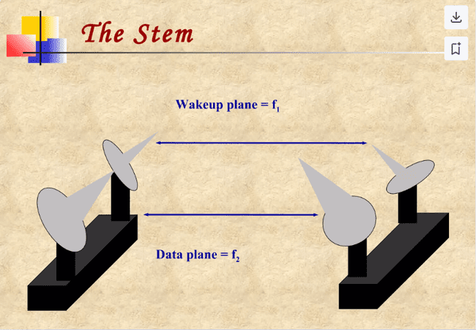

**ROUTING LAYER**

This section explores energy-efficient routing techniques developed specifically for WSNs, focusing on extending network lifetime.

Key concepts of WSN routing include:

Routing Approaches:

1. Multi-Hop Routing: In WSNs, data is usually sent over multiple hops from a source node to the BS. The BS can be fixed or mobile, serving as a gateway between the sensor network and external systems, such as the Internet. Multi-hop routing is energy-efficient, as direct communication with the BS can be energy-intensive for distant nodes.
2. Energy-Efficient Routing Goals: The primary aim is to minimize energy consumption and maximize network lifetime. WSN routing protocols use specific strategies, including **data aggregation, clustering, in-network processing, and data-centric techniques to meet this goal.**

**Classification of Routing Protocols for WSNs**

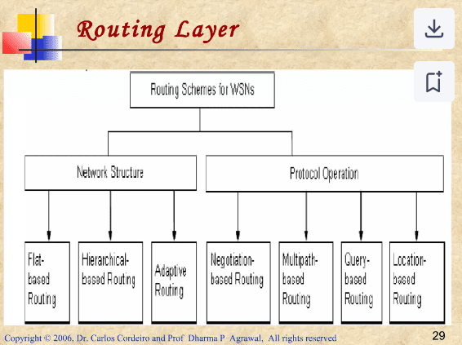

Routing protocols in WSNs can be classified based on **network structure and protocol operation.**

**By Network Structure:**

* **Flat-based Routing**: All nodes have equal roles, and data is typically forwarded based on query responses. This approach is suitable for small networks.
* **Hierarchical-based Routing**: Nodes play distinct roles; some nodes (cluster heads) are designated with additional responsibilities, such as aggregating data and forwarding it to the BS. This approach conserves energy by reducing redundant data Transmission and is commonly used in large WSNs.
* **Adaptive Routing**: Protocols adapt parameters based on current network conditions, such as energy availability, to maintain efficiency.

**By Protocol Operation**:

* **Multipath-based Routing**: Utilizes multiple paths for data transmission to increase reliability and load balancing.
* **Query-based Routing**: Nodes send data in response to specific queries, saving energy by limiting transmissions to relevant data only.
* **Negotiation-based Routing**: Prevents redundant data transmission through negotiation among nodes before data forwarding.
* **Location-based Routing**: Nodes use location information to route data, optimizing routes and reducing transmission energy costs.

**Considerations for WSN Routing:**

1. **Energy Conservation Priority**: Energy efficiency is prioritized over data quality to prolong network lifespan.
2. **Stationary Nodes**: Many applications assume nodes are stationary, favoring table-driven routing protocols over reactive schemes to reduce energy spent on route discovery.
3. **Cooperative Routing**: Sensor nodes collaborate by sending data to a cluster head (CH), which aggregates the data and further processes it, reducing overall route cost in terms of energy use.
4. **Use of Timing and Position Information**: Certain protocols leverage time and position data for efficient routing, adapting routes as network conditions and node locations change.

***Network Structure Based***

***Flat Routing***

In flat routing based protocols, all nodes play the same role.

**Directed Diffusion**

Directed Diffusion operates through a process involving **data aggregation and in-network processing**, which helps reduce redundant transmissions and save energy. Here’s an overview of the Directed Diffusion process:

1. **Interest Propagation**: The base station (BS) initiates communication by broadcasting an "interest" that specifies a task to be fulfilled by the network. This interest diffuses through the network hop-by-hop, with each node broadcasting it to its neighbors.
2. **Gradient Setup**: Each node that receives an interest establishes a gradient—a direction of data flow—towards the node from which it received the interest. This gradient setup forms paths from multiple data sources to the BS, allowing data to flow towards the requesting node. Different gradients may be formed to neighbors with varying strengths, affecting data flow.
3. **Data Transmission and Path Reinforcement**: Once data is transmitted, paths are refined by reinforcing the best paths to ensure efficient routing and prevent further flooding. The BS may also periodically refresh the interest to maintain data flow, as the wireless medium can be unreliable.
4. **In-network Aggregation**: As data flows along these gradients, nodes aggregate information from various sources, reducing the number of transmissions and minimizing energy consumption.
5. **Event-Specific Propagation**: Directed Diffusion is well-suited for ongoing or persistent queries, where nodes continuously provide data over time, such as monitoring environmental conditions. However**, it may not be efficient for one-time or historical queries, as setting up gradients for a single-use path can be unnecessary**.

By aggregating data and choosing optimized paths, Directed Diffusion conserves energy, extends network lifetime, and improves robustness.

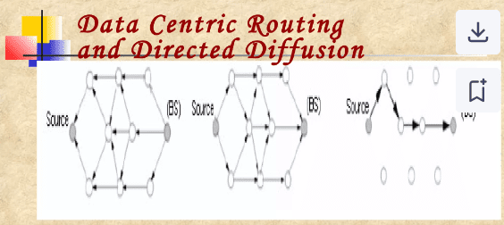

**Hierarchical Routing** is a type of cluster-based routing approach in wireless sensor networks (WSNs) aimed at improving energy efficiency and scalability. By organizing nodes into clusters, hierarchical routing protocols achieve a balanced load across the network, where energy-intensive tasks are primarily handled by selected nodes called Cluster Heads (CHs).

Key Concepts of Hierarchical Routing

1. Cluster Formation and Role Assignment: Nodes in a WSN are organized into clusters, with each cluster containing a designated CH. Regular sensor nodes within a cluster perform sensing and data collection tasks and then relay this data to their CH. The CH, typically a higher-energy node, is responsible for aggregating data and sending it either to an upper-level CH or directly to the Base Station (BS).

2. Energy Efficiency: By aggregating data, CHs reduce the number of transmissions and the energy spent in data transfer. Since data is aggregated at the cluster level before reaching the BS, this hierarchical approach minimizes communication cost, conserves node energy, and enhances the network's lifespan.

3. Scalability: Hierarchical routing supports a scalable architecture by limiting communication within clusters and only forwarding processed data to higher layers. This structure is especially beneficial in large networks where a direct transmission from each node to the BS would be inefficient and unsustainable.

Example: **Cluster-Based Routing Protocol (CBRP)**

The Cluster-Based Routing Protocol (CBRP) is a fundamental protocol proposed by Jiang (1998) that segments the network into clusters of two-hop-diameter. Each node only communicates with its CH, which is responsible for further routing data. However, CBRP has some notable limitations for WSNs:

- High Overhead: CBRP requires frequent "hello" messages to establish and maintain clusters, which consumes significant network energy and bandwidth.

- Stationary Nodes: In most WSN applications where nodes are stationary, the overhead created by continuous hello messaging becomes unnecessary and reduces overall efficiency.

**Adaptive Routing** protocols are designed to dynamically adjust to the available resources and network environment, aiming to conserve energy and improve communication efficiency in Wireless Sensor Networks (WSNs). One prominent family of adaptive routing protocols is the

**Sensor Protocols for Information via Negotiation (SPIN)**

**Key Concepts of Adaptive Routing with SPIN**

1. **Data-Centric Communication**: SPIN protocols assign high-level metadata to data packets, allowing nodes to negotiate the data before transmission. This data-centric approach prevents the transmission of redundant information since nodes only send data that their neighbors lack.
2. **Energy Adaptation**: SPIN adapts to each node’s available resources, ensuring that low-energy nodes reduce participation when energy is scarce. This energy-awareness prevents nodes from expending energy on unnecessary transmissions, prolonging the network’s operational lifespan.
3. **Three-Stage Communication**: SPIN protocols follow a three-stage communication process using three types of messages:
   * **ADV**: Advertises new data.
   * **REQ**: Requests specific data that the node does not possess.
   * **DATA**: Transmits the actual data when requested.

This process continues iteratively until all nodes in the network have the information they need.

**Types of SPIN Protocols**

* **SPIN-1 and SPIN-2**: These are the foundational protocols of the SPIN family. SPIN-1 handles basic data negotiation, while SPIN-2 includes a threshold-based energy mechanism. When a node's energy level drops below a certain point, it only participates in data transmission if it can complete the process without falling below the threshold.
* **SPIN-BC (Broadcast Channel)**: SPIN-BC is optimized for broadcast environments. Nodes delay their responses with random timers, avoiding redundant requests when multiple nodes request the same data.
* **SPIN-PP (Point-to-Point)**: For point-to-point communication, SPIN-PP operates with a three-way handshake similar to SPIN-1 but requires only single-hop neighbor awareness. This protocol is effective for networks where energy and data reliability are less of a concern.
* **SPIN-EC (Energy-Constrained)**: This variant uses an energy threshold heuristic. Nodes participate only if they can complete all stages without reducing energy below a predefined threshold.
* **SPIN-RL (Reliable)**: In error-prone environments, SPIN-RL adds mechanisms to SPIN-PP to manage lossy channels. Nodes track received ADV messages and can request retransmissions for data not received within a time window, ensuring reliable data transfer.

**Advantages of SPIN**

* **Energy Efficiency**: By negotiating metadata before full data transfer, SPIN reduces unnecessary data exchanges and conserves energy.
* **Adaptability**: SPIN adjusts to the network’s energy levels and only participates when feasible, extending node life.
* **Reduced Redundancy**: By eliminating redundant data transfers and only transmitting unique data, SPIN conserves bandwidth and energy.

**Limitations**

SPIN protocols, while energy efficient and suitable for mobile WSNs, are not always ideal for networks with strict latency requirements or real-time demands. **The delay from negotiation and the overhead from ADV and REQ messaging can be excessive in dense networks** or environments where rapid data dissemination is needed.

Negotiation-Based Routing protocols in Wireless Sensor Networks (WSNs) aim to eliminate redundant data transmissions by using high-level data descriptors to negotiate and decide what data should be sent. This approach addresses common issues of traditional flooding, such as **implosion** (nodes receiving duplicate data) and **data overlap** (when nearby nodes collect similar data). These problems lead to unnecessary energy consumption and bandwidth use, which is particularly problematic in resource-constrained WSN environments.

**Negotiation-Based Routing**

1. **High-Level Data Descriptors**: Nodes use metadata to describe the data, allowing them to negotiate on the data's necessity before initiating a full transmission. This negotiation avoids sending redundant data to neighboring nodes.

2. **Resource-Based Communication Decisions**: By evaluating the available resources, nodes can make adaptive decisions on whether to participate in data transmission, thus conserving energy.

3. **Avoiding Redundant Data**: Protocols like SPIN (Sensor Protocols for Information via Negotiation) are classic examples of negotiation-based routing. In SPIN, each sensor node describes its data using metadata and broadcasts this information through ADV (advertisement) messages. Neighboring nodes then request data they need, minimizing duplicate data transmissions.

**Advantages**

- **Energy Efficiency**: By preventing redundant transmissions, negotiation-based protocols conserve energy across the network, especially vital for WSNs.

**- Reduced Data Overlap**: Nodes avoid receiving unnecessary duplicates of data, which reduces data processing and storage demands.

**Multipath-Based Routing** is a routing approach in Wireless Sensor Networks (WSNs) that maintains multiple paths from a source to a destination, instead of relying on a single path. This routing method aims to improve network fault tolerance and reliability by providing alternative paths, especially useful in the event of primary path failure. However, maintaining these paths incurs extra energy consumption and overhead as they require periodic messages to keep the alternate paths active.

Key Features of Multipath-Based Routing

1. **Enhanced Fault Tolerance**: The likelihood of having an alternative route when the primary path fails increases with multiple paths, which improves overall network resilience.

2. **Node-Disjoint and Overlapping Paths**: Paths can be node-disjoint (no shared nodes) or overlapping. Node-disjoint paths increase reliability but are more resource-intensive, while overlapping paths reduce resource consumption.

3. **Energy-Optimized Path Selection**: Paths can be selected based on residual energy to avoid rapid depletion of energy in any single path, thus extending network lifetime. For instance, the primary path may be used until its energy drops below that of a backup path.

**Approaches and Protocols in Multipath Routing**

- **Suboptimal Path Selection**: Some protocols use suboptimal paths probabilistically based on energy consumption, enabling more even distribution of network load.

- **Reliability via Redundancy**: In unreliable environments, certain protocols send duplicate data over multiple paths to ensure message delivery. This approach balances reliability and energy consumption by using a redundancy function dependent on the **failure probabilities of the paths.**

- **Directed Diffusion and Braided Paths**: Protocols like Directed Diffusion utilize braided paths (partially disjoint) close to the primary path to lower the maintenance cost of multipath routing, allowing energy-efficient recovery from failures.

**Applications of Multipath Routing**

This approach is ideal for time-critical and high-reliability applications such as:

- Explosion Detection

- Intrusion Detection

- Forest Fire Monitoring

These applications often require service differentiation, **where critical queries take the shortest path, and non-critical, periodic updates are distributed over longer paths**. This differentiation extends network life by reducing battery depletion in specific nodes, as it spreads out the workload across the network, particularly in mesh or rectangular grid-based WSNs.

**Query-Based Routing** in Wireless Sensor Networks (WSNs) enables on-demand data retrieval by having nodes propagate queries for specific data (sensing tasks) throughout the network. In this model, a destination node, such as a base station (BS), issues a query to the network, and nodes that hold relevant data respond by sending matching information back to the requester. This approach helps in scenarios where continuous monitoring isn’t necessary, conserving network energy by only activating nodes when a specific data query is made.

**Key Components of Query-Based Routing**

1. **Query Propagation**: The BS or destination node sends a query, often in natural language or a high-level query language, to all or part of the network. Nodes store these queries and will respond with relevant data whenever it matches their sensing tasks.

2. **Interest Propagation and Gradient Paths**: In Directed Diffusion, the sink node initiates interest messages to SNs, setting up gradients (data pathways) from the source back to the sink. When a source has data matching the interest, it sends it back along these paths, and energy is conserved by aggregating data (e.g., suppressing duplicates) along the way.

**Rumor Routing**

The Rumor Routing Protocol provides an efficient mechanism to handle localized queries. Here, long-lived "agents" traverse the network, creating paths to events they encounter:

- **Event-Based Path Creation**: Agents update nodes with paths to events as they move around. Each agent contains an event table that synchronizes with the nodes it visits, enabling them to record and recall the paths to various events.

- **Agent Optimization**: If an agent finds a more efficient route, it updates the routing tables of nodes it encounters, optimizing future queries.

- **Efficient Querying Mechanism**: A node queries only if it has learned a path to the target event. If no route exists, the node broadcasts the query randomly and waits. If the query fails, it may resort to network flooding to ensure the request reaches the destination.

**Applications and Advantages**

Query-based routing is highly suitable for event-driven scenarios like battlefield monitoring, where queries for specific data (e.g., "Are there vehicles in region 1?") need to be answered without constantly sensing and transmitting data across the network.

**Energy efficiency is achieved by:**

1. Activating nodes only when relevant queries are issued.

2. Reducing redundant data transmission via data aggregation techniques.

3. Avoiding continuous monitoring and data broadcasting across the entire network.

This method makes query-based routing ideal for applications with intermittent data requirements, where on-demand information retrieval can save energy and bandwidth across WSNs.

**Location-Based Routing** in Wireless Sensor Networks (WSNs) leverages the geographic positions of sensor nodes (SNs) for addressing and routing, optimizing the network's efficiency by minimizing data transmission distances and reducing energy consumption. Nodes can determine their locations via signal strength estimations or GPS receivers, provided the nodes are GPS-enabled.

**Key Components of Location-Based Routing**

1. **Location Awareness**: Nodes use relative positions, calculated through signal strength or GPS, to identify their locations. Relative positioning between nodes allows for efficient communication without needing full network knowledge.

2. **Energy Conservation through Sleep Scheduling**: To maximize energy savings, certain location-based schemes involve putting nodes into sleep mode when they are inactive, allowing only essential nodes to remain active to maintain network functionality.

- **Localized Sleep Scheduling**: In such schemes, the sensor field is divided into small grid sections or "squares," and only one node per square remains active, while others sleep. This localized activity management conserves energy while ensuring continuous network connectivity and data communication capabilities.

**Advantages and Applications**

**- Extended Network Lifetime**: By reducing the number of actively transmitting nodes and minimizing redundant communication, location-based routing maximizes the network’s energy efficiency.

- **Spatial Coverage and** **Connectivity**: Location-based routing schemes are designed to ensure that active nodes can cover the entire sensing area, maintain network connectivity, and provide essential routing functions.